**Q) Once you have a mechanism to estimate the “level of default”, please describe how the financial institution must use that mechanism to decide whether to approve or decline the prospect for the loan they are applying for?**

These are top features needs to be considered for approving the loan.

***Important Features:***

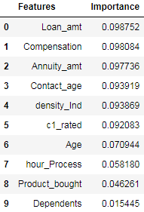

Loan amount - needs to be in the range of 3-4 times of the Income of the person.

Annuity amount - should be in good amount because the person is repaying or not he is making default with the loan he taken previously.

Contact_age - because for availing loan the person may get a new number with fake details.

c1 rated - the credit score should be high for the person who is applying for the loan.

Age - should be minimum because the tenure for the loan can be given more.

Product_bought - the person is buying any products frequently with credit links and repaying the credit loan.

Dependents - no of person dependent on the person for calculating the repaying capacity.

***Business Insights -***

These are the important points to be checked for the person before approving the loan. That the concern person will make the loan default or non default.

The addition of new Features ( **Tenure, Repayment capacity, attractive Rate of Interest and flexible tenure** ) will help to make identify the person will make the loan default or non default of the loan amount taken by the person.